Name :SK.Kashifa

Registration no :192121135

Credit card processsing system

Class diagram :

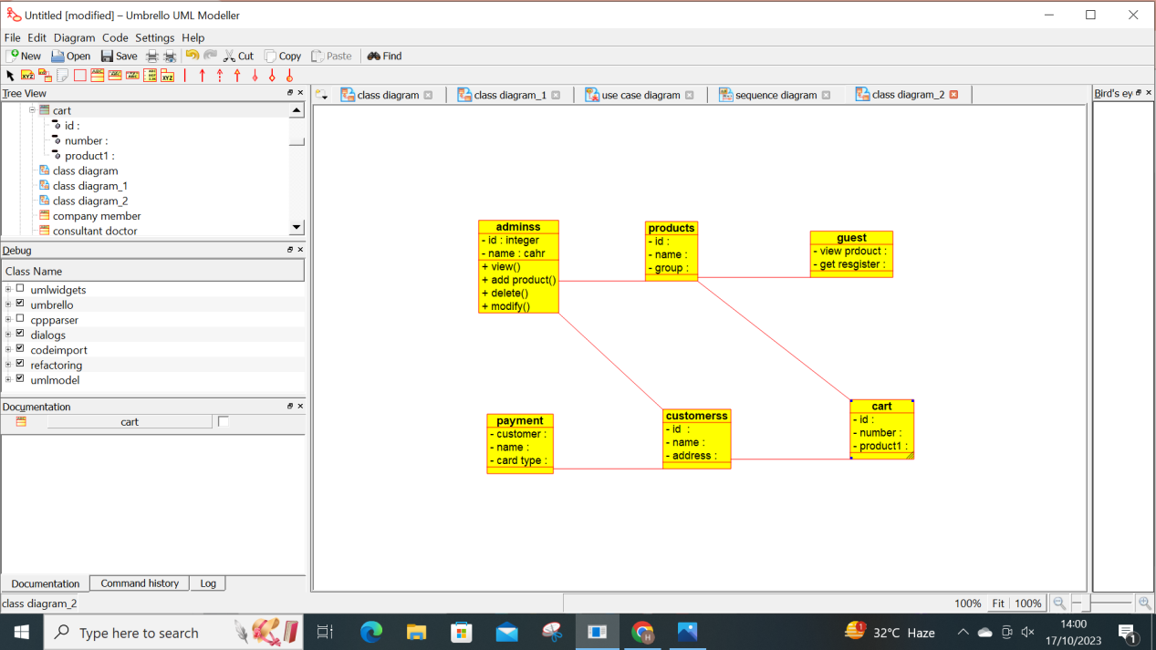

Sequence diagram :

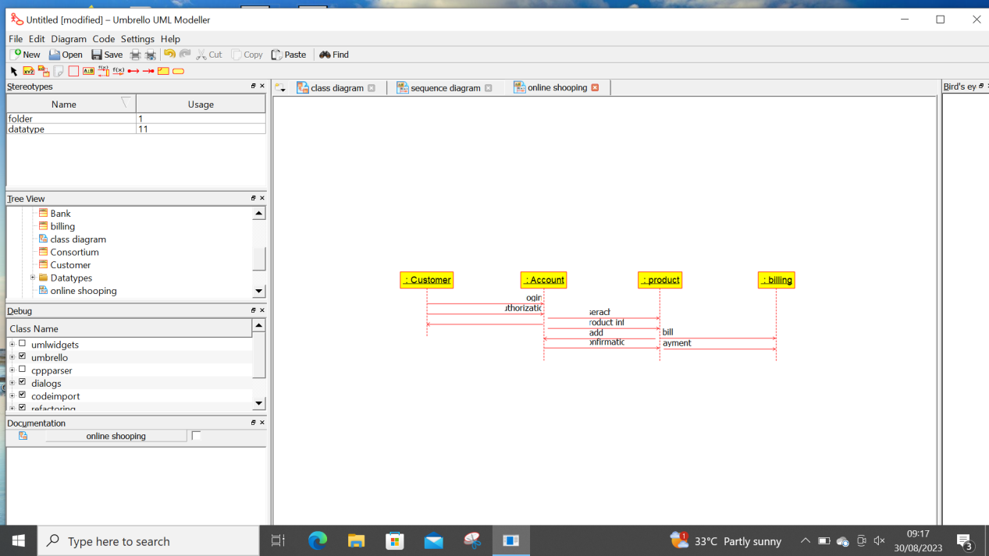

Activity diagram :

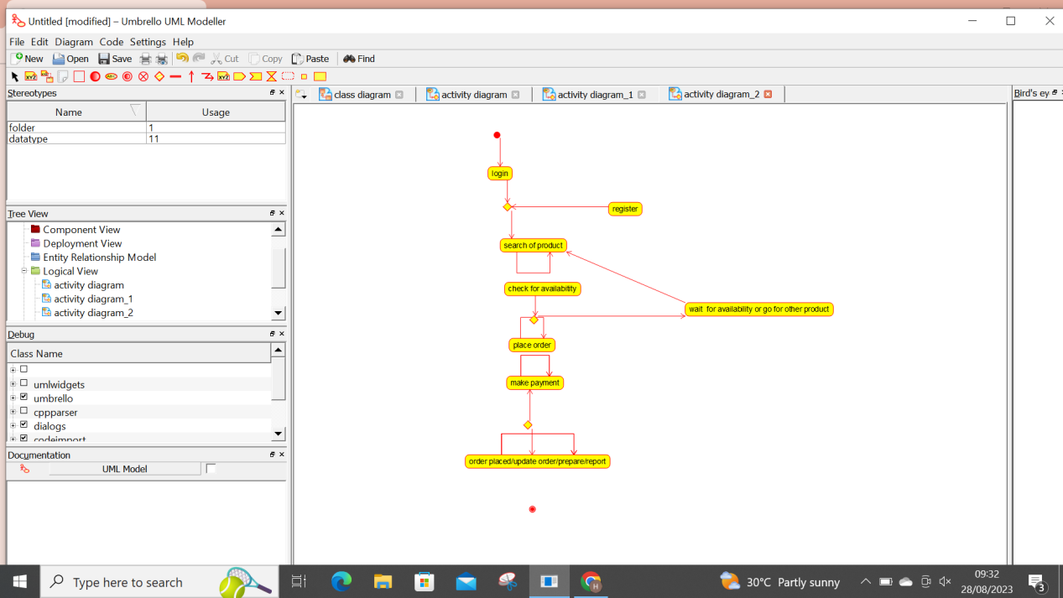

A